Free Youtube views for an unlimited number of your videos! Boost your video's popularity using their simple and free method! Or, buy Youtube views and other services here.

[ythunder.com](https://ythunder.com/) has free & open registrations.

Have you ever wonder and desire how to get more views on your [YouTube](https://ythunder.com/) videos? Would you want to get more of what you have right now? Why [YouTube](https://ythunder.com/)? Why SEO? This article can educate you and help you at the same time in bursting those views off the chart. Free Youtube views：[ythunder.com](https://ythunder.com/)

Let us talk about why and how you can benefit from using SEO on [YouTube](https://ythunder.com/).

Why is it Effective to Use on [YouTube](https://ythunder.com/)?

[YouTube](https://ythunder.com/) is known as the second largest search engine following Google. [YouTube](https://ythunder.com/) is built for searching content using videos. [Youtube](https://ythunder.com/) is not like any other social media with the likes of Facebook, Twitter and Instagram are more of a social connection between a person to the other, but it does not help you in having views and that long term traffic for your videos.

*Image:* [*Youtube*](https://ythunder.com/)*. Screenshot was taken on August 22, 2022*

Although social media is a gateway for doing online stuff like businesses, [YouTube](https://ythunder.com/) is a far greater help in having your views go sky-high, it has the personnel and equipment that can help you on whatever issue or subject you are creating. You just got to know how to place your content for easy access whenever there are people who search for something related Free Youtube views：[ythunder.com](https://ythunder.com/)

to your videos, and it would pop up.

What is SEO?

SEO means search engine optimization. Keywords are the main component of Search Engine Optimization. The basis of using SEO is that your video will show up whenever they type any keyword that your video has in Lead Generation in Google.

The reward is great if you have done the SEO right. It can get free traffic for your videos every single day. All you need is a lot of patience if you are just getting started, as the results from SEO will take some time. Remember, the higher your video ranks on the website, the higher the prize waiting for you as you can garner more views that can lead to sales or more businesses. One other way is to pay ads for faster results, but learning it is far tougher as it involves money.

Why You Need to Focus on Creating [YouTube](https://ythunder.com/) SEO?

The first thing to be concerned with videos is having a business, as they stay online forever and your video is within reach for people who have an internet connection all over the world.

Videos made from a few years back can still get sales even after today. It’s like you will be working on a video once, and the revenue will keep coming over and over again.

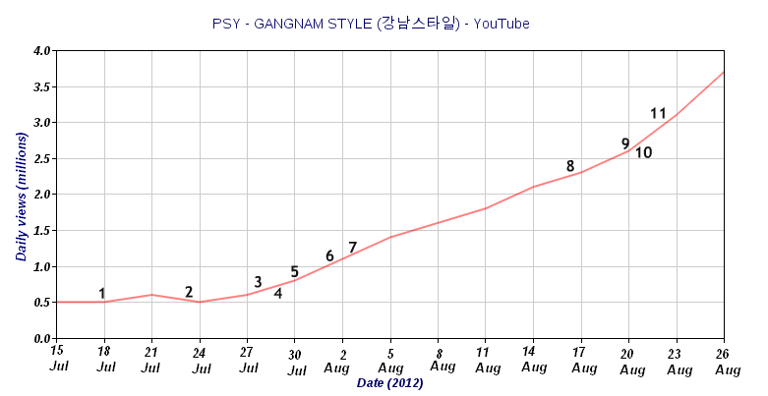

*Image: Gangnam Style Analytics. Photo taken from Wikimedia Commons*

If you even look back on the videos from your past posts and the present, you can identify the gradual improvement and difference. You will see how far you’ve become and with each video, it’s getting better.

The Time it takes to see the results from

It will take days to a few weeks to know where your video will rank. A good way to make your video to rank is to find a keyword that has a slim to no chance of other contests. In that way, you could rank up instantly. There are other factors on how a video ranks, such as backlink, watch time, and social interaction. While waiting for the results or if you do not rank instantly, you may shift your focus on your SEO.

*Image: Sample Funny Videos Search Ranking. Screenshot was taken on August 22, 2022*

Humble Beginnings

You are going to start at the bottom. Every first video is not a successful one, or in other words, a disaster. As time goes by, you will learn and apply changes that would benefit your videos. Learn to be optimistic and go up for the challenge of being better at creating videos. As the saying goes, practice makes perfect, so practice until you are satisfied with your work.

*Camilla Cabello’s first* [*YouTube*](https://ythunder.com/) *Video on her First* [*YouTube*](https://ythunder.com/) *Account*

Coming up for the Contents of Your Video

You may come up to nothing when it comes to ideas because every idea has been taken up by other people. But, it does not mean that it has all the same ways of delivering it to the audience. Even if the others made the content, what is important is how you deliver the content. Delivery is the key to attract the audience.

For example, when you were in school, you tend to learn from various teachers but of the same subject. Have you ever wondered how students want a certain teacher because of how they deliver every topic of the subject? That’s the same point in creating a concept. It does not matter if you have some concepts; what matters is how are you going to deliver it.

Equipment to use in Shooting Videos

Considering you are a first-time creator, it is best to be resourceful. The best thing to use is what you have right now, which is your smartphone. In today’s era, smartphones are also considered as a digital camera or video camera. The quality may not be as good as a high-end video camera, but it can still be useful. If you don’t own a smartphone, you may also use your laptop as it has a built-in camera. Better yet, if you have the money to buy more sufficed equipment, you can always go to the store to buy a video camera. But as said earlier, if you are starting, be resourceful.



*Image: Equipment used for* [*YouTube*](https://ythunder.com/)*. Photo taken from Envato*

The Creation of a Great Video

They say the hardest part is getting started. You will have hesitations whether you will do it now or later, but you should begin to something to achieve something. All you need to have is courage, to make the video and upload it. It wouldn’t be your best, but it certainly is the start of your video journey. Now, to help you create your first video, here are the four steps in creating good content:

* **Introduction** – Introduce yourself, where are you from, what are you going to do.
* **Question** – Ask yourself or the audience a question.
* **Content** – Answer the question and answer it as creative as you can.
* **Call to Action** – Tell the audience what you want them to do. The “click Like, Subscribe, and Share button.”

The Four SEO Tips and How to Get More Views

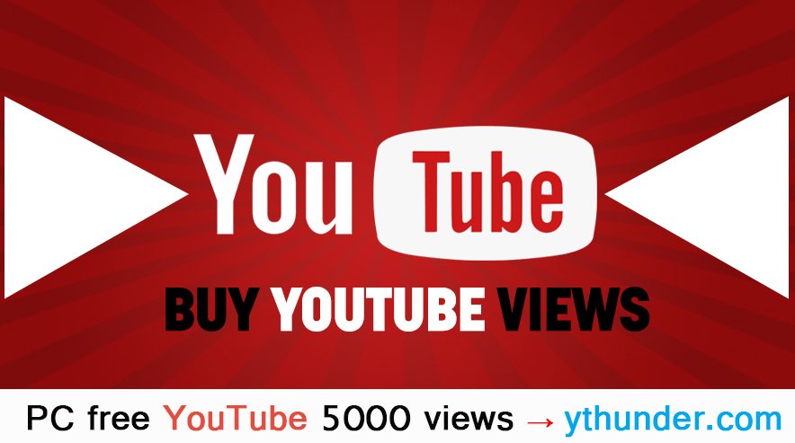

And now for the 4 SEO Tips to get your videos more views and get it right in front of your audience on the internet. Follow these four steps in recording a video.

1. Make sure when creating the video file name, it has the keyword in it. Keep in mind that you need to do it before uploading as you can’t change once you upload the video.
2. The keyword is always present in the Title of your video. Having a good title is the key to your video, but if it does not sound right, then don’t force it.
3. Get some tagging, tag videos that are relevant to your videos.
4. Get a good description of your videos with the keyword and other words that can support your keyword. Remember, use the keywords and supporting words often as possible, especially also in the tagged videos.

Making Money From Your Ranked Videos

Having more views means more income. There are a lot of ways on how to make money using your videos. There are a lot of effective methods you can use to attain views and money. We will give you just a gist on some methods.

* **Affiliate Marketing** – Finding a product you like or used and promoting it on your channel. It is a simple yet effective way to gain profit. Just keep in mind that whatever product you choose must be connected with your target market. You also should not promote products you haven’t used yet.
* **Selling Own Products** – the pros of this method is that you can get all the profit, but it needs to be still connected to the topic of your channel.

The Best SEO Tool to Use in [YouTube](https://ythunder.com/)

Using keywords is not enough to boost the rank of your videos. So we thought of it on how can you enhance more views for your videos. A tool to use other than using keywords is **Tubebuddy**. What does Tubebuddy do to help you?

*Image: TubeBuddy. Photo taken from TubeBuddy*

* Subtotal called keyword explorer that states when or where it is essential to add tags that are appropriate to your video.  It could amp up your game in gathering views as it will tell you where will your video will rank for a keyword.  It also has a checklist so you may get a heads up on what you’ve done or what is needed to be accomplished. It also has a canned response to purposely answer frequently asked questions. This is just a suggestion to make your work more efficient and easy. You can check it if you want to experience it first-hand.

It is a Learning Experience

To sum it all up, you always need to focus on using keywords and making the content worthwhile. Name your video with keywords that can relate to your target market. Always support your video with tags. Guarantee a video that would answer and solve the problem of the audience. Keep in mind that patience is a virtue and always be on the lookout on how much more you can do to boost your rank, and never forget to tend the customer’s needs.

Free Youtube views for an unlimited number of your videos! Boost your video's popularity using their simple and free method! Or, buy Youtube views and other services here.

[ythunder.com](https://ythunder.com/) has free & open registrations.